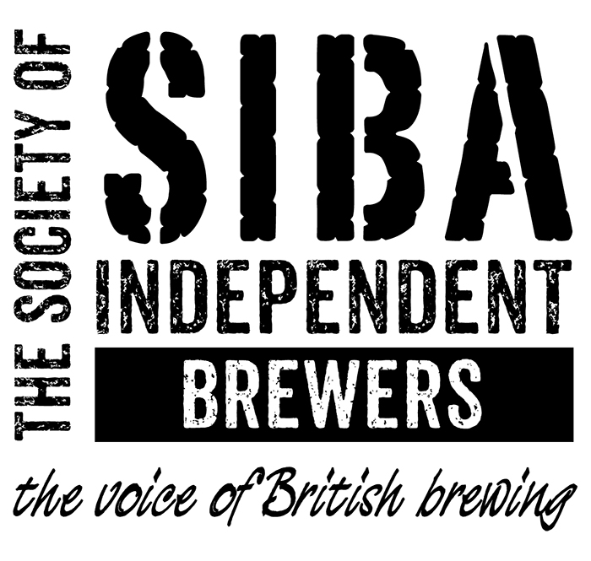
Head of Public Affairs and Communications

June 2017

Candidate Information: Job Description, person specification and application process

Position: Head of Public Affairs and Communications
Location: London/South East preferred as regular availability at Westminster is essential. Home-based role.
Reports to: Chief Executive
Closing date: 3rd July 2017.

Introduction

SIBA, the Society of Independent Brewers, was formed in 1980. As a trade association we represent more than 850 independent British craft breweries. We provide support services for our members and create commercial opportunities through a number of different initiatives.

It is an exciting and challenging time for SIBA and for Britain’s independent craft breweries and there are now more breweries per head of population than in any other country. A key challenge for SIBA is ensuring professional brewing businesses have sustainable access to market to meet the demand for quality local beer from discerning beer drinkers. SIBA’s vision ‘to deliver the future of British beer and become the voice of British Brewing’ is challenging and exciting and our Head of Public Affairs and Communications will be an important part of our professional staff team focusing on our vision and delivery of our strategic plan.

Job Overview

You will be tasked with delivering first-rate internal and external communications including overseeing PR activity alongside building the profile of SIBA and its key issues with Governments and parliamentarians in Westminster, Scotland, Wales and Northern Ireland as well as at a European level. You will build contacts, identify opportunities, monitor policy, represent SIBA and raise the awareness of and support for our professional brewing business members, establishing SIBA as their voice. You will develop our public affairs and communications strategy as well as devising and delivering plans for individual projects and campaigns and advising the Chief Executive as the Society’s main spokesperson.

Purpose of the role

- Provide an effective Public Affairs and communications function
- Build profile, opportunities and contacts
- Develop public affairs and communications strategies to deliver SIBA’s aims and objectives
- Plan and deliver campaigns
- Organise events
- Represent SIBA
- Advise on policy issues
- Monitor parliamentary activity and policy issues and advise accordingly

The Package

- Starting salary will be in the range £40,000-45,000 and is dependent on qualifications and experience.
- Permanent position on successful completion of three month probationary period
- Contributory pension scheme on successful completion of probationary period
- Performance review at three, six and twelve months in the first year and at least annually thereafter
- Some travel in the UK and occasionally abroad
- Travel and subsistence expenses paid
- Home-based; SIBA offices located in Ripon and Burton Upon Trent
- Staff benefits include group life and income protection cover

Responsibilities and key deliverables

- Develop public affairs strategies to deliver SIBA’s vision and strategic aims
- Devise and implement tactics to build engagement and support for SIBA and its aims with the UK, Welsh, Scottish and Northern Irish Governments, civil servants and parliamentarians as well as the European Commission and Parliament.
- To oversee SIBA’s campaign media relations, managing the press-related activities of the PR and Marketing Manager
- To deliver effective internal and external communications for the trade association and commercial activities
- Work effectively with other colleagues, most notably the Director of Membership & Marketing and the Chief Executive
- Monitor, communicate and advise upon upcoming policy developments, the political climate and the progress of relevant bills or other activity including maintaining a public affairs timetable and calendar for SIBA
- Provide appropriate briefing documents at all levels
- Provide general lobbying advice and support to the Chief Executive and Chairman
- Build engagement programmes with SIBA members and ensure SIBA’s Executive and Board are suitably briefed on lobbying issues and activity
- Provide general lobbying advice and support to members in dealing with MPs, etc
- Research and write responses to relevant consultations
- Manage a public affairs and communications budget
- Manage a contact database and a contact diary/timetable
- Identify and maintain relationships with relevant All-Party Parliamentary groups
- To ensure SIBA has appropriate crisis and reputational damage management plans in place
- Build and manage relationships and partnerships with key industry stakeholders
- Work with the PR and Marketing Manager to make best use of social media and on-line campaigning in SIBA’s public affairs activity
- Provide support on multi-disciplinary campaigns as required
- To be an active member of the Senior Management Team sharing responsibility for delivering SIBA’s strategic plan
- Any other duties as may reasonably be required

Person Specification

Education, skills and experience

Essential | Desirable
Several years experience in public affairs and communications, including management positions | At least five years relevant experience
Undergraduate Degree | Relevant subject to at least 2:1
Excellent knowledge of the workings of government and parliamentary procedures | Extensive established MP and parliamentary contacts
Strong political knowledge and understanding and a genuine interest in politics | Management experience in a membership organisation
Demonstrable experience of developing successful public affairs strategies and plans | Experience of internal communications in a membership organisation
Experience of managing and delivering multi-disciplinary campaigns | A good understanding of Social Media
In-depth experience of managing and delivering public affairs projects | Data and statistical analysis skills
Good IT skills including Microsoft Office
Excellent communication skills verbally and written
The ability to influence people at all levels
The ability to provide accurate concise and easy to understand briefings on complex subjects
Strong research skills
Excellent presentation skills
Experience of being able to work alone and collaboratively
Strong ability to prioritise and manage challenging workloads often under pressure
Demonstrable experience as a senior representative of an organisation

Personal Qualities

Essential | Desirable
Intelligent and analytical
Excellent communication and networking skills | Passionate and driven
Ability to build evidence based arguments | A passion for great beer
Strong self-awareness and resilience under pressure | Enthusiasm and passion for politics
A diplomatic but persuasive approach
Decisive and confident
A team worker with excellent inter-personal relations
Committed to member/ customer service
Problem solver and strategic thinker
Extremely confident and convincing communicator
Evidence of continuous professional development

Practical

Ability to travel as required
Ability to work effectively from home

Application Process

The closing date for receipt of applications is 5pm on Monday 3rd July 2017.

Applications received after this date will not be considered. Please send your c.v. and a covering letter addressed to Mike Benner, Chief Executive outlining in no more than two sides of A4 what you will bring to the role and how you meet the person specification and send to mike.benner@siba.co.uk

If you wish to have an informal discussion about the role please contact Mike Benner by email to arrange a telephone conversation.

You’ll find more information about SIBA, including our strategic plan, at www.siba.co.uk.

Shortlisted candidates will be invited to attend an interview in mid-July. You may be asked to prepare a presentation to make during the interview and a second interview may follow.

Any job offer will be on the understanding that the information provided is full and correct and not misleading and that no relevant information has been omitted. An inaccurate or misleading application will be grounds for summary dismissal under SIBA’s disciplinary procedure.

Please provide details of any previous criminal convictions (Rehabilitation of Offenders Act applies)

SIBA is an Equal Opportunities employer

ENDS

